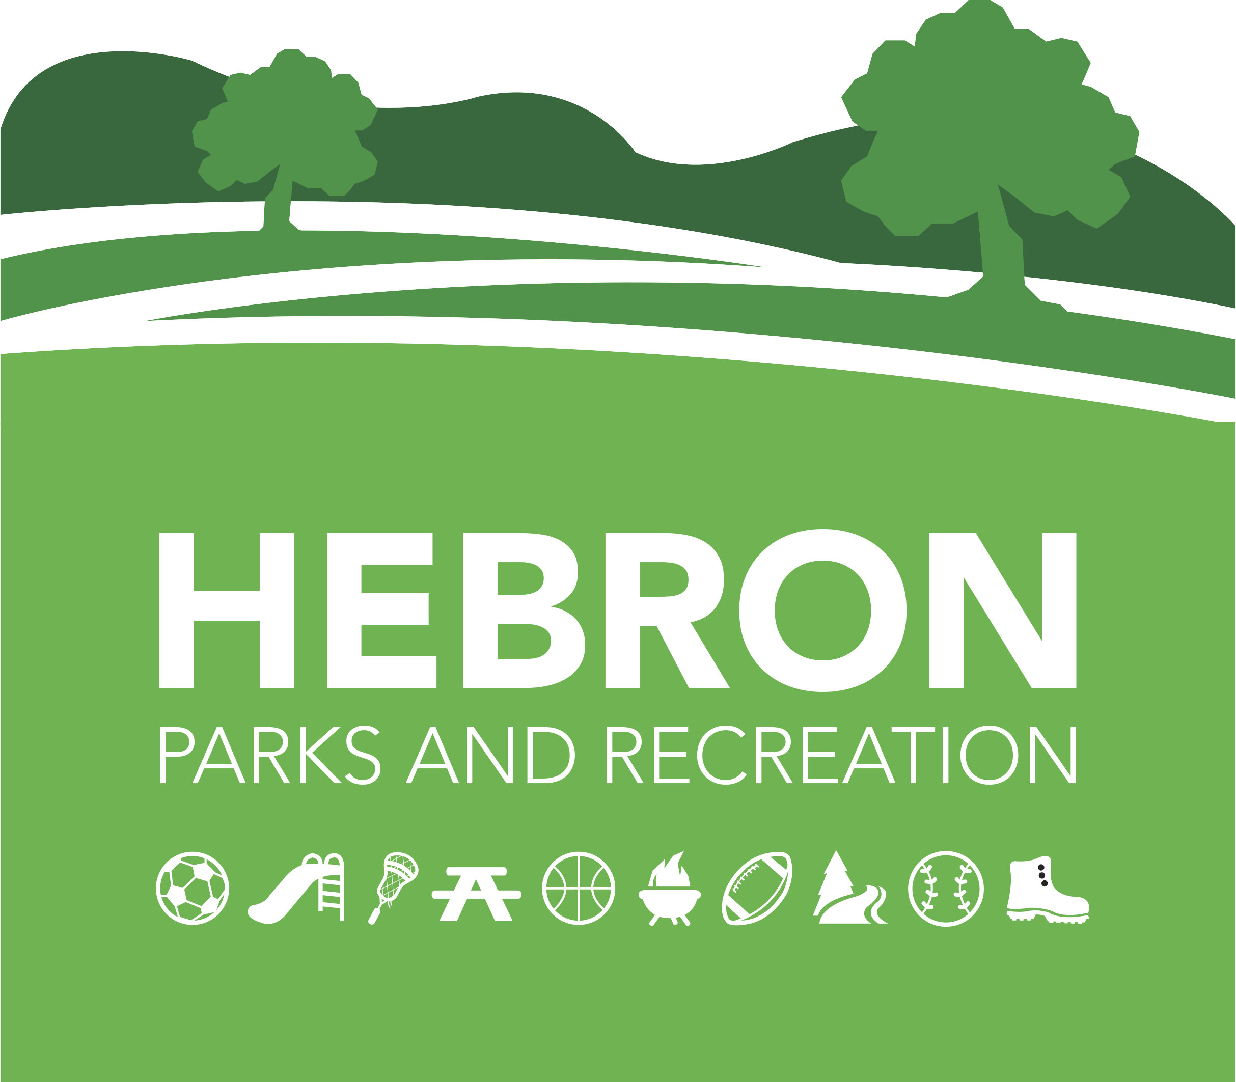
Hebron Parks & Recreation Department
Mailing Address Office Location
15 Gilead Street 148 East Street
Hebron, CT 06248 Hebron, CT 06248
860-530-1281 www.hebronct.recdesk.com/community
860-228-5912 Fax

PREP Registration Form
Grades Pre-K- 6
2023- 2024 School Year

Dear PREP Families,

Families who have children currently enrolled in the PREP Program have first preference to re-enroll their children, and/ or to ENROLL A SIBLING for the next program year. Please note that your currently enrolled PREP student(s) must finish out the program year in order to retain preferential status for next year.

Over the years we have made numerous changes in the PREP Program, working closely with the school system, opening for extended hours on school delays and signing the District Transfer of Information form. This year we have added an updated payment option with a base pay rate for pick up prior to 5:00 o’clock and a PM Extended Care option for an additional fee if needed. As always, we are working closely with the school staff to provide consistent policies and procedures.

To reserve you spot for next year, please complete and return all the attached forms, including the Bus Form, updated Immunization Records per child, and the completed check list with $100 deposit for one child, and $150 for a family of 2 or more that will be put towards the first month of PREP tuition.

The $100/ $150 deposit covers part of your tuition for September. Please note that fees have not changed for the 2023/2024 year. Checks should be made payable to “Town of Hebron.” The deposit is non-refundable; however, you can decide to surrender your place at any time by notifying us in writing. The remaining balance for the first month of PREP is due by August 11, 2023. Registration will not be accepted without all forms completed. Please also note that registration will not be taken unless we have a credit card on file.

If you have any questions about the process, please call the Parks and Recreation office at 860-530-1281.

Sincerely,

Erica Santos Craig Bryant
Recreation Supervisor Director

Hebron Parks & Recreation Department
Mailing Address Office Location
15 Gilead Street 148 East Street
Hebron, CT 06248 Hebron, CT 06248
860-530-1281 www.hebronct.recdesk.com/community
860-228-5912 Fax

DOCUMENT CHECKLIST

- Deposit (not accepted without completed Pick Up/Drop off Request Form)

- PREP Enrollment Registration Form

- Signed Contract

- Emergency Contact/ Pick-up Form

- Credit Card Authorization Form *not accepted without

- Authorization for the Administration of Medication *if applicable

- Transfer of Confidential Student Information *if applicable

- Tuition Schedule (keep for your records)

- Completed Transportation Pick Up/Drop off Request Form *must complete

- COVID-19 Guidelines *subject to change

- Must attach up to date immunization records for each child *not accepted without

Hebron Parks & Recreation Department
Mailing Address Office Location
15 Gilead Street 148 East Street
Hebron, CT 06248 Hebron, CT 06248
860-530-1281 www.hebronct.recdesk.com/community
860-228-5912 Fax

PREP ENROLLMENT RESERVATION 2023-2024

Parent/ Guardian Name: _______________________________ Phone: _________________

Address: _____________________________________________________________

Cell: ___________________ Email: _______________________________________

Parent/ Guardian Name: _____________________________ Phone: ___________________

Address: _____________________________________________________________

Cell: ___________________E-Mail: ______________________________________

Please list each child separately
Please mark, on the appropriate line, to indicate the type of care you wish to reserve for each child.
Child’s Name | Date of Birth | Grade in Sept 2023 | AM Care 6:45-8am | PM Care 2:45-5pm | PM Extended Care  5 –6:00pm

To register your child(ren) for PREP, please submit the following to Hebron Parks & Recreation:
- Completed PREP Registration packet. All forms must be complete, including the Bus Form. *Registration will not be accepted without all forms.
- $100/$150 deposit
Mail to: Hebron Parks & Recreation Department, 15 Gilead Street, Hebron, CT 06248
In person: Hebron Parks & Rec. Office- Burnt Hill Park, 148 East Street, Hebron, CT 06248

Town of Hebron, Parks & Recreation
PREP Contract
Effective September 1, 2023 through June 16, 2024*

I, ______________________________________________, have read, understand, and hereby agree to abide by the policies set forth by the Town of Hebron Parks & Recreation Enrichment Program (PREP). All my questions have been asked and answered, and I agree to abide by the policies of the program.

I agree to pay the tuition for my child(ren) on a monthly basis, according to the specifications of the ‘Monthly Payment Schedule.’ Tuition is due on the third Friday of the preceding month.

I agree to pay all incurred late fines or fees for additional program hours, as necessary.

____ I agree that my credit card will be kept on file and will be charged the day after the due date.

I agree to provide two weeks’ written advance notice to the Parks & Recreation Office for the purpose of scheduling vacation time for my child.

I agree to provide two weeks written advance notice with payment to the Parks & Recreation Office if I choose to withdraw my child(ren) from the program.

School Vacations and Staff Development Days are an additional fee. I also understand that my child is not guaranteed a slot for Vacation and Staff Development days, and that sign-up for these weeks will be on a first-come, first-served basis.
I understand that failure to abide by the program policies may result in my being asked to find more appropriate care for my child elsewhere.
**I do give permission to have my child(ren) photographed and/ or videotaped for use in the Parks & Recreation Enrichment Program and/ or by Town of Hebron Parks & Recreation Department. I understand that the photograph(s) and/or videotapes will be used for activity purposes or for publications.

I hereby give approval for my child to participate in the above listed Hebron Parks & Recreation Department program. I agree to assume all risks and hazards incidental to this program(s), including transportation to and from the site of said program. I hereby waive, absolve, indemnify, and agree to hold harmless the Town of Hebron, the department, the commission, supervisors, instructors, and participants from claims arising out of injury to myself/ my child. Any injuries will have to be covered by the individual's insurance.

____________________________________ _______________________
Signature of Parent/ Guardian Date

*Subject to change based on the school calendar

Hebron Parks & Recreation PREP
Pick-Up & Emergency Contact Reference 2023/2024

Child’s Name: ________________________ D.O.B. _________________ Grade: ________

Address: _____________________________________________ Phone # _______________

List any allergies or medical conditions:______________________________________________
______________________________________________________________________________

List any medications taken regularly:________________________________________________

______________________________________________________________________________

Parent/ Guardian’s Parent/ Guardian’s
Full Name:___________________________ Full Name:_______________________________

Address: _____________________________ Address: _________________________________

Home # ____________Work/Cell___________ Home # ____________Work/Cell____________

Email_________________________________ Email___________________________________

List (3) Other Individuals who should be contacted, to pick-up or call, if neither parent can be reached:

Name: _________________________Phone:_______________ Relation to child: ______________

Name: _________________________Phone:_______________ Relation to child: ______________

Name: _________________________Phone: ______________ _Relation to child: ______________

Child’s Pediatrician: _____________________Town: ______________ Phone:_________________

Hospital Preference: ________________________________________________________________

In case of an emergency, I give permission for Hebron Parks and Recreation Enrichment Program (PREP) to provide my child with medical attention as deemed necessary.

Parent/Guardian Signature____________________________________ Date_______________________

Parent/ Guardian Signature____________________________________ Date_______________________

Hebron Parks & Recreation Department
Mailing Address Office Location
15 Gilead Street 148 East Street
Hebron, CT 06248 Hebron, CT 06248
860-530-1281 www.hebronct.recdesk.com/community
860-228-5912 Fax

Credit Card Authorization

*Registration will not be taken unless we have a credit card on file. *

Child(ren) Name:___________________________________________________________________

Street:________________________________________ Town: __________________Zip__________

Credit Card Information:

Credit Card Type_______________________ Credit Card #__________________________________
Exp. Date____________ 3-digit CVV #: _____________

I authorize that my credit card be kept on file and will be charged five days after the due date.

I hereby authorize the Hebron Parks & Recreation Department to credit my charge card for monthly Tuition payments to the “PREP” program, and any other charges which I specifically authorize.

Printed Name: ______________________________________ Date: _____________________

Signature: ___________________________________________ Date: ______________________

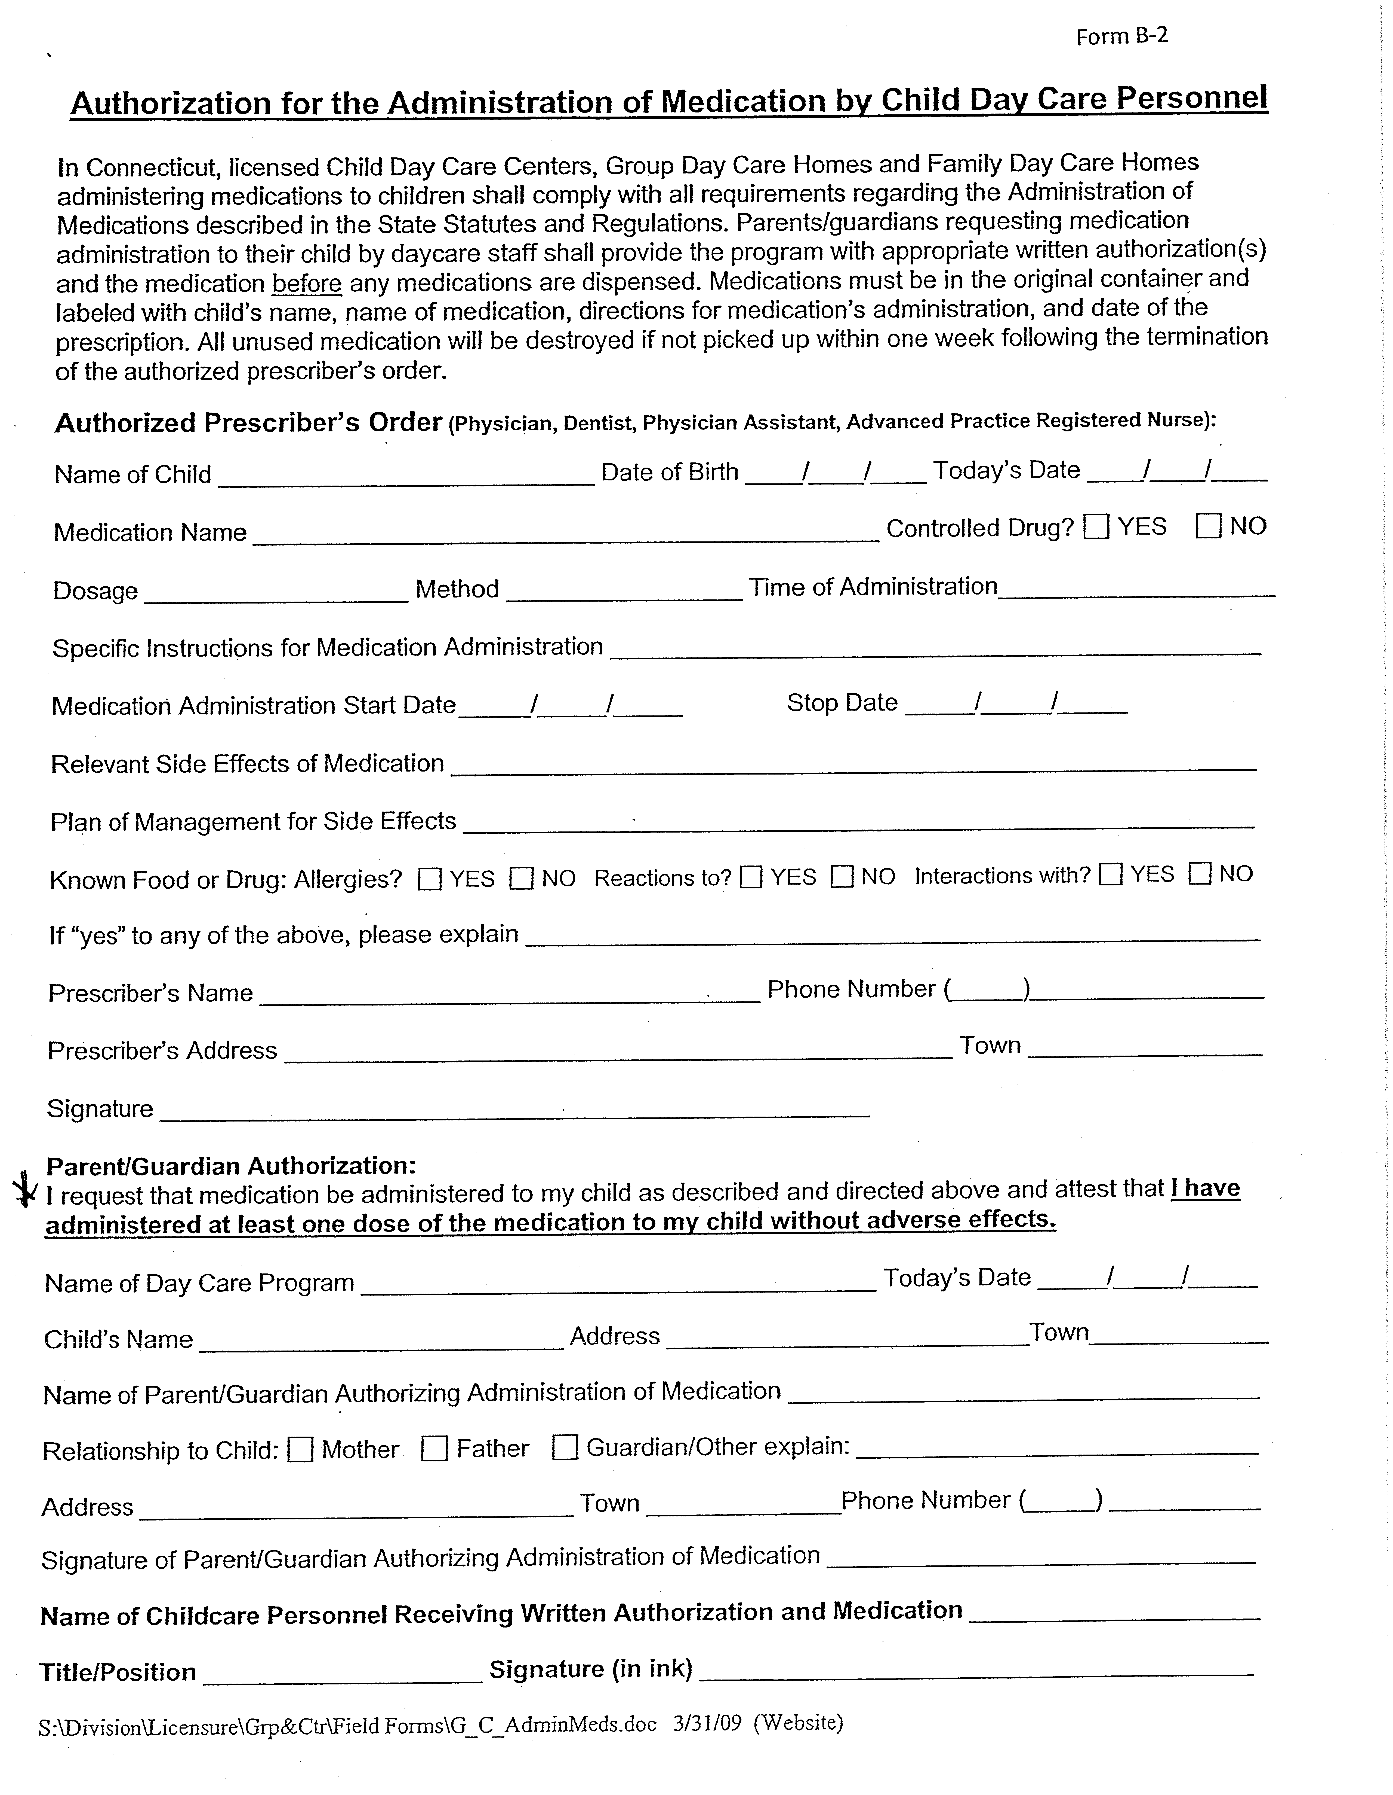

HEBRON PUBLIC SCHOOLS

TRANSFER OF CONFIDENTIAL STUDENT INFORMATION

Date: ___________________

Pursuant to the Family Educational Rights and Privacy Act (“FERPA”), I hereby authorize the Hebron Public Schools and their agents to release and/or obtain (please circle) the following confidential records regarding my child:

Name of Child: _____________________________________________
Address: _____________________________________________
_____________________________________________
_____________________________________________
_____________________________________________
DOB: __________________

Parent(s)/Guardian(s):____________________________________________
School: _____________________________________________

(Please check all that apply)
Obtain Release
All Records □ □
Cumulative File □ □
Pupil Personnel/Special Education □ □
Disciplinary □ □
Health/Medical* □ □
Other (please specify) □ □
_______________________________

_______________________________

To/From: ___________________________________________________________________________
Name
Address: ______________________________________________________________________________
Street Town State/Zip Code

Telephone: (_______)_______________ Fax: (________)_______________________

I understand that the information to be disclosed is protected as an “education record” under FERPA, and that such information shall not be redisclosed unless permitted under FERPA. I further understand that the officers, employees, and agents of any party that receives protected information under FERPA may use such information only for purposes for which the disclosure is made.
___________________________________ ____________________
Signature of Parent/Guardian Date

___________________________________
Print Name of Parent/Guardian

HEBRON PUBLIC SCHOOLS

TRANSFER OF CONFIDENTIAL STUDENT INFORMATION – pg. 2

********************************************************************************************************
*If this authorization is being used to obtain Protected Health Information from a child’s physician or other covered entity under HIPAA, the following section must also be completed:

I, the undersigned, specifically authorize _______________________________ to disclose my child’s
Name of Physician__________________________________________________________,

medical information, as specified above, to my child’s school,
Name of School____________________________________________________________,

at the above address for the purposes described below (i.e. health assessment for school entry, special education evaluation etc.):
_______________________________________________________________________

By signing below, I agree that a photocopy of this authorization will be valid as the original. This authorization will be valid for a period of one year from the date below. I understand that I may revoke this authorization at any time by notifying the physician’s office in writing, but if I do, it will not have any effect on actions taken by the Physician prior to receiving such revocation.

I understand that under applicable law, the information disclosed under this authorization may be subject to further disclosure by the recipient and thus, may no longer be protected by federal privacy regulations.

I understand that my child’s treatment or continued treatment with any health care provider or enrollment or eligibility for benefits with any health plan may not be conditioned upon whether or not I sign this authorization and that I may refuse to sign it.

Any information received by the school pursuant to this authorization is subject to all applicable state and federal confidentiality laws governing further use and disclosure of such information.

___________________________________ ____________________
Signature of Parent/Guardian Date

___________________________________
Print Name of Parent/Guardian

4/6/09
238848 v.36 S5

 |  | 2023-2024 PREP Tuition Schedule
 | MONTHLY RATES:
 |  |  | AM | PM | PM EXTENDED
 | Date | # weeks/mo. | Care | Care | Care
 |  |  | 6:45-8:15 | 3:00-5:00 | 5:00-6:00
 | September
 | (Payment due 8/13) | 4.00 | $196.00 | $344.00 | $360.00
 | October
 | (Payment due 9/15) | 4.00 | $196.00 | $344.00 | $360.00
 | November
 | (Payment due 10/220 | 4.00 | $196.00 | $344.00 | $360.00
 | December
 | (Payment due 11/17) | 4.00 | $196.00 | $344.00 | $360.00
 | January
 | (Payment due 12/15) | 4.00 | $196.00 | $344.00 | $360.00
 | February
 | (Payment due 1/19) | 4.00 | $196.00 | $344.00 | $360.00
 | March
 | (Payment due 2/16) | 5.00 | $243.00 | $430.00 | $452.00
 | April
 | (Payment due 3/16) | 3.00 | $147.00 | $258.00 | $270.00
 | May
 | (Payment due 4/20) | 4.00 | $196.00 | $344.00 | $360.00
 | June
 | (Payment due 5/18) | 2.00 | $98.00 | $172.00 | $180.00
 |  | 38.00
Please note- A credit card MUST
be on file.

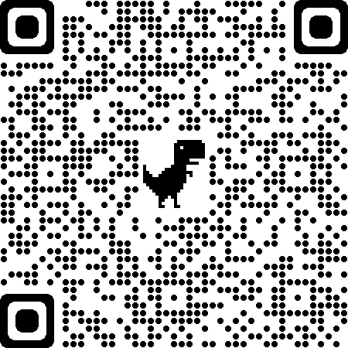
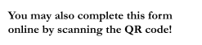
Hebron Public Schools

Alternate Pick Up/Drop Off Request Form 2023-2024 School Year
(For pick up/drop off OTHER than the students primary home address)

Please submit by July 1, 2023
Please contact the Hebron Board of Education Central Office at 860-228-2577 with any questions related to this form.
Multiple children can be included on a single form, however, please only use this form for children with identical transportation requests.
Bus routes are developed based on home addresses. Please complete this form each year ONLY if you are requesting a pick up/drop off other than your home address, or if you do not intend to have your child(ren) ride the bus.Requests may be granted under the following circumstances:
- The request is for 3 months or more (exceptions may be granted by the Superintendent in the event of emergencies.)
- The location of the special request is on an existing route to and from the child's school.
- There is space available on the bus (preference is given to students who reside on the route; therefore, a student who has received a transportation request may have this permission revoked at any time.)
- The location of the AM pick up and PM drop off may be different but must be consistent Monday through Friday.
- This request will not disrupt the bus schedule as determined by the administration.
- Any adjustment submitted after July 1st may not be accommodated by the 1st day of school to provide adequate time for bus routes to be mapped. Mid-year adjustments must be submitted 5 business days in advance of the requested start date.

Student Name(s) Grade for 2023-2024

Student Home Address:

Morning Pick Up:
My child will take the bus from their home address
My child will take the bus from an alternate address (e.g: Daycare/Prep/Babysitter)
Supervising Adult’s Name: Supervising Adults Address: Supervising Adults Phone Number:
My child will not need bus transportation in the morning.

Afternoon Drop Off:
My child will take the bus to their home address.
My child will take the bus to an alternate address (e.g: Daycare/Prep/Babysitter)
Supervising Adult’s Name: Supervising Adults Address Supervising Adults Phone Number:
My child will not need bus transportation in the afternoon.

Parent/Guardian Signature Date

PREP COVID-19 GUIDELINES

- PREP is considered an outside of school program meaning that all exposures to a COVID positive person inside of the PREP program will follow the CDC guidelines as well as the school guidelines for out of school exposure.
- If your child tests positive for COVID, they are required to isolate and quarantine for 5 days, regardless of vaccination status. They may return to school and the PREP program after the 5th day from their positive test, as long as they remain wearing their masks properly for another 5 days.
- Please contact the Parks and Recreation Department as well as the School Health Office to make them aware if your child has tested positive for COVID or is quarantining as a close contact
- A fully vaccinated person is defined as below:
  - 11 years and younger
    - Completed the primary series of Moderna, Pfizer, or Johnson and Johnson and has been over 2 weeks since last shot
  - 12 years and older
    - Completed the primary series of Moderna, Pfizer, or Johnson a Johnson and is boosted
    - Completed the primary series of Moderna or Pfizer in the past 5 months
    - Completed the primary series of Johnson and Johnson within the last 2 months
- An unvaccinated person is defined as below:
  - 11 year and younger
    - Are unvaccinated or have not completed a primary series of vaccination
    - Have completed the primary series of Moderna, Pfizer, or Johnson and Johnson but are has been less than 2 weeks since last shot
  - 12 year and older
    - Are unvaccinated or have not completed a primary series of vaccination
    - Completed the primary series of Moderna or Pfizer over 5 months ago and is not boosted
    - Completed the primary series of Johnson and Johnson over 2 months ago and is not boosted

- All close contacts considered fully vaccinated are not required to quarantine from school or PREP in the case of exposure but must wear a mask for 10 days.
- All close contacts considered unvaccinated are required to quarantine immediately for 5 days, including from both school and the PREP program. They may return after the 5 days as long as they have not shown any symptoms and are required to wear a mask for the remaining 5 days.
- If either fully vaccinated or unvaccinated feel sick or develop symptoms, they should stay home and get tested.

PREP STAFF-
- All PREP staff has completed a town wide COVID-19 training.
- Staff have been instructed to not report to work should they not feel well, have any symptoms consistent with COVID-19 or have had close contact with a person diagnosed with COVID-19
- Should any staff member have a fever or have any symptoms consistent with COVID-19 they will be sent home immediately
- Fully vaccinated staff and students will not quarantine so long as they remain symptom free
SUPPLIES-
- All PREP classrooms are well equipped and stocked with the following items:
  - Handheld thermometers
  - Hand sanitizer
  - Disinfectant wipes
  - Soap
  - Paper towels
  - Disinfectant spray
  - Disposable masks (should anyone misplace theirs as it is your responsibility to provide a mask or face covering for your child).
SIGN IN/ DROP OFF AND PICKUP-
- Parents are not permitted in the building.
- Parents will be greeted by a staff member at the main PREP door/ hallway. The staff member will sign the child in and assist the child to their room
- We no longer require daily temperature screenings
- When picking up, parents will be greeted by a staff member who will retrieve the child for you and sign the child out. Please remember that parents are not allowed in the building.

MONITORING OF ILLNESS-
As a reminder, families should not send a child to school if the child is sick or had contact with someone who is either presumed or confirmed positive for COVID-19.
If you are awaiting COVID-19 test results due to illness or contact with others, you must wait until these test results are in before sending your children to school/ PREP. When in doubt, keep children at home and contact the school health office.
Should a child not feel well, have a fever or any other symptoms during the PREP program, the child will be isolated in an area in one of our PREP rooms and the parent will be called to immediately pick up the child.
In the event of a confirmed COVID-19 case within the school or PREP program, the PREP program will follow protocols and instructions given by the BOE, school health office, and Chatham Health District.
SOCIAL DISTANCING-
- All students and staff will maintain social distancing of 4 feet apart to the greatest extent possible
MASKS & FACE COVERINGS-
- Beginning Monday, February 28, 2022, the use of masks/ face coverings during the PREP Before and After School Program will be optional for all students and staff. Please remember that the use of masks/ face coverings is still required for students and staff while on school transportation (busses).

- HAND WASHING/ SANITIZING-
- Hand sanitizer and hand soap is provided in each PREP room
- All staff and children are required to wash their hands upon arrival, before and after meals, after bathroom use and after coughing or sneezing
- Weather permitting, all PREP classrooms will utilize the windows being open, to ventilate fresh air
CLEANING-
- PREP staff will clean the rooms daily, using disinfectant wipes and sprays, including:
  - Tables
  - Chairs
  - Toys & supplies (please note that non-wipeable toys, such as stuffed animals, are prohibited in the program and will not be used)
  - Doorknobs
  - Sinks
SHARING-
In order to prevent transmission among the school and PREP program, there will be NO sharing of any kind. This includes food, toys, supplies, etc. Please limit the number of items sent to the program with the child.

BATHROOMS AND WATER FOUNTAINS-
In order to prevent transmission among the school and PREP program, the water dispensers and water fountains located in the PREP classrooms will not be accessible. The school will have touchless water bottle fillers so please send your child to the program with a fillable water bottle.
All bathrooms are thoroughly cleaned by the school custodial staff. There will be a limited number of children allowed in the bathroom. Touchless soap, sanitizer and towel dispensers have been installed by the schools, in hallways and bathrooms.

We understand that getting young children to follow these guidelines is difficult, so we are asking for your help in ensuring that they do so. The safety of our children and staff are our number one priority. If these guidelines are not adhered to, it may result in removal from the PREP program.

I confirm that I have read, understood, and agree to the above information, guidelines, procedures, and policies. I understand that should these procedures and policies not be followed; it may cause removal from the PREP Before and After School Program.

____________________________ __________________
Signature Date

